Cam 2 settings

Fast kinetics with Na F1 imaging, 4/26/18

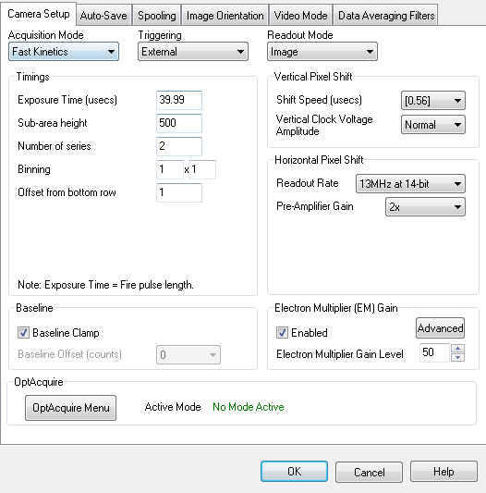

1/15/19 Settings with BEC panel after upgrading to new control computer

